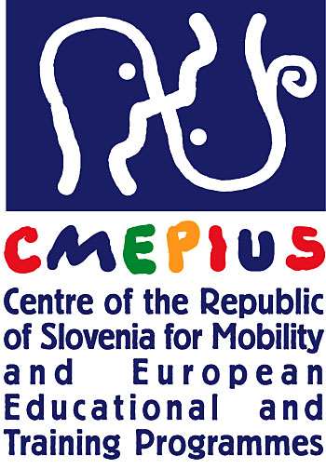
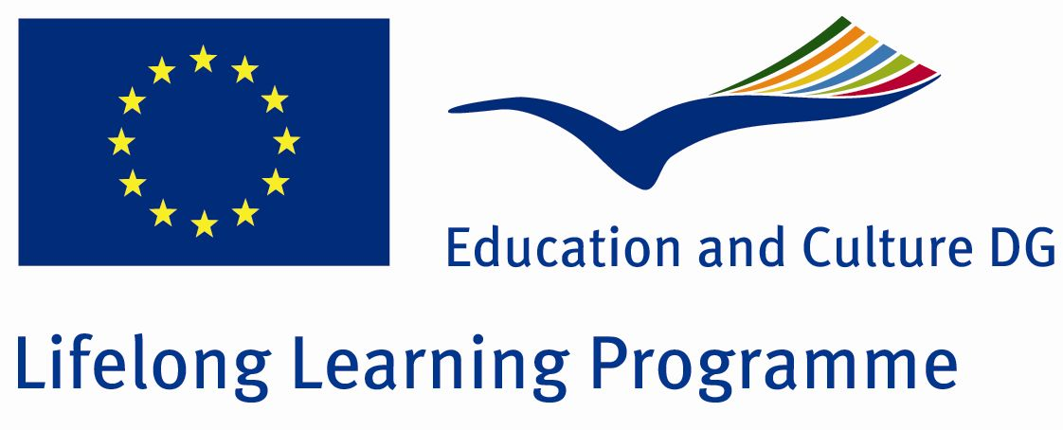

GRANT AGREEMENT

For an Action

AGREEMENT NUMBER — 7401-2010

TRANSFER OF INNOVATION, LEONARDO DA VINCI
LIFELONG LEARNING PROGRAMME

PROJECT NUMBER — 2010-1-SI1-LEO05-01628

CONTRACT BETWEEN THE BENEFICIARY AND THE PARTNER

This contract, drawn up under the action programme in the field of lifelong learning, Leonardo da Vinci (Decision N°1720/2006/EC of the European Parliament and of the Council of 15/11/2006 establishing an action programme in the field of lifelong learning, published in the Official Journal of the EU N°L327/45 on 24/11/2006) shall govern relations between:

GASILSKO RESEVALNA SLUZBA KRANJ
Bleiweisova cesta34
4000 Kranj hereafter named "the Beneficiary"

represented by

Vojko Milivoj Artai, Director

on the one hand
and

Universitätsklinikum Aachen
Pauwelsstraße 30
52074 Aachen, Germany hereafter named "the Partner"

represented by

bitte den ‘legal representative’ mit Name und Funktion einfügen

on the other hand,

Which have agreed as follows:
Article 1/Subject

- Having regard to the provisions of Decision N°1720/2006/EC of the European Parliament and of the Council of 15/11/2006 establishing an action programme in the field of lifelong learning, published in the Official Journal of the EU N°L327/45 on 24/11/2006 establishing the action programme in the field of lifelong learning "Leonardo da Vinci", the Beneficiary and the Partner commit themselves to carrying out the work programme covered by this contract.
This work programme comes under the Agreement n° 7401-2010 concluded between the Beneficiary and the National Agency.

- The total cost of the project for the contractual period referred to by the Agreement n° 7401-2010, all financing combined, is estimated at 203.105,26 EUR (including all taxes and duties).

- The maximum Leonardo da Vinci contribution to cover expenditure incurred by the members of the Partnership participating in the programme shall be 141.611,56 EUR.

- The final financial contribution shall depend on the evaluation of the quality of the results of the project described under the Agreement n° 7401-2010 concluded between the Beneficiary and the National Agency, pursuant to the rules laid down at Community level, particularly in the Administrative and Financial Guidelines (cf. Annex III), but shall, under no circumstances, give rise to a profit.

- This contract shall regulate relations between the parties, and their respective rights and obligations with regard to their participation in the project described under the Agreement n° 7401-2010 concluded between the National Agency and the Beneficiary.

- The subject matter of this contract and the related work programme are detailed in the annexes, which form an integral part of this contract and that each party declares to have read and approved.

Article 2/Duration

- The project referred to in Article 1 has a duration of 24months. It starts 19.11.2010 and ends on 18.11.2012.

- This contract enters into force on the date of signature by the last of both participating parties to the contract and terminates at the moment of payment of the balance of the contract, as mentioned in Article 7.1.

- The period of eligibility of the costs starts on 19.11.2010 and finishes 18.11.2012.

Article 3/Obligations of the Beneficiary

The Beneficiary shall undertake:

- to take all the steps necessary to prepare for, perform and correctly manage the work programme set out in this contract and in its annexes, in accordance with the objectives of the project as set out in the Agreement n° 7401-2010 concluded between the National Agency and the Beneficiary;

- to send to the Partner a copy of the Agreement n° 7401-2010 and its annexes, concluded with the National Agency, of the Administrative and Financial Guidelines (cf. Annex III), of the various reports and of any other official document concerning the project;

- to notify and provide the Partner with any amendment made to the Agreement n° 7401-2010 concluded with the National Agency;

- to define in conjunction with the Partner the role and rights and obligations of the two parties, including those concerning the attribution of the intellectual property rights;

- to comply with all the provisions of Agreement n° 7401-2010 binding the Beneficiary to the National Agency.

Article 4/Obligations of the Partner

The Partner shall undertake:

- to take all the steps necessary to prepare for, perform and correctly manage the work programme set out in this contract and in its annexes, in accordance with the objectives of the project as set out in the Agreement n° 7401-2010 concluded between the National Agency and the Beneficiary;
- to comply with all the provisions of Agreement n° 7401-2010 binding the Beneficiary to the National Agency;
- to communicate to the Beneficiary any information or document required by the latter that is necessary for the management of the project;
- to accept responsibility for all information communicated to the Beneficiary, including details of costs claimed and, where appropriate, ineligible expenses;
- to define in conjunction with the Beneficiary the role and rights and obligations of the two parties, including those concerning the attribution of the intellectual property rights.

Article 5/Financing

- The total expenditure to be committed by the Partner for the period covered by this contract is estimated at 38.598 EUR (including all taxes and duties).
- The Leonardo da Vinci contribution for the Partner shall be a maximum amount of 23.000 EUR.

Article 6/Co-financing

The Partner's financial contribution to the project amounts to 15.598 EUR.

Article 7/Payments

- The Beneficiary commits himself to carrying out payments relating to the subject matter of this contract to the Partner according to the achievement of the tasks and according to the following schedule:

1st payment: 40% of the LdV contribution for the partner
2nd payment: 30% of the LdV contribution for the partner
final payment: 30 % of the LdV contribution for the partner

- All payments shall be regarded as advances pending explicit approval by the National Agency of the final report, the corresponding cost statement and the quality of the results of the project.

- Any revenue generated by the project and received by the Partner shall be declared in the financial statement and shall limit the Leonardo da Vinci financial contribution to the amount required to balance revenue and expenditure. Any revenue shall be declared and communicated to the Beneficiary.

Article 8/Bank account

Name of the bank
Full address
Postcode/City/Country
IBAN Code
BIC Code
Account no.
Remarks for bank transfer
Name of account holder
Address of account holder
Postcode/City/Country

Article 9/Reports

- The Partner shall provide the Beneficiary with any information and document required for the preparation of the interim report and, where appropriate, with copies of all the necessary supporting documents completed and signed by the legal representative by 19.11.2011 at the latest.

The Partner shall provide the Beneficiary with any information and document required for the preparation of the final report and, where appropriate, with copies of all the necessary supporting documents completed and signed by the legal representative within 1 month following the closing date at the latest.

Article 10/ Value Added Tax (VAT)

- The Partner declares that he has [no] possibility to recover value added tax (VAT) for his expenses.
- The VAT percentage in the Partner’s country amounts to 19%.
- The Partner declares that the costs in the interim and final report for this project are calculated according to the national regulations which his institution is subject to.

Article 11/ Monitoring and supervision

- The Partner shall provide without delay the Beneficiary with any information that the latter may request from him concerning the carrying out of the work programme covered by this contract.
- The Partner shall make available to the Beneficiary any document making it possible to check that the aforementioned work programme is being or has been carried out.
3. The obligations described in Article 19 of the Agreement n° 7401-2010 apply mutatis mutandis to the Beneficiary and partner.

Article 12/ Liability

- Each contracting party shall release the other from any civil liability in respect of damages resulting from the performance of this Agreement, suffered by itself or by its personnel, to the extent that these damages are not due to the serious or intentional negligence of the other party or its personnel.
- The Partner shall protect the National Agency, the Beneficiary and their personnel against any action for damages suffered by third parties, including project personnel, as a result of the performance of this contract, to the extent that these damages are not due to the serious or intentional negligence of the National Agency, the Beneficiary or their personnel.

Article 13/Termination of the contract

- The Beneficiary may terminate the contract if the Partner has inadequately discharged or failed to discharge any of the contractual obligations, insofar as this is not due to force majeure, after notification of the Partner by registered letter has remained without effect for one month.
- The Partner shall immediately notify the Beneficiary, supplying all relevant information, of any event likely to prejudice the performance of this contract.

Article 14/ Jurisdiction clause

- Failing amicable settlement, the Courts of Kranj shall have sole competence to rule on any dispute between the contracting parties in respect of this contract.
- The law applicable to this contract shall be the law of Slovenia

Article 15/ Amendments or additions to the contract

Amendments to this contract shall be made only by a supplementary Agreement signed on behalf of each of the parties by the signatories to this contract.

Annexes

a) detailed budget relating to the activities of the Partner (costs associated with the activities and sources of financing).
b) description of the Partner's tasks and breakdown of the Leonardo da Vinci allocation.

Done at Kranj, in two copies.

For the partner For the Beneficiary

The legal representative Vojko Milivoj Artai
(name and function) Director

[ signature & stamp] [ signature & stamp]

[ date ] [ date ]
Annex

Partner’s budget

Staff  Costs  [€] | Travel and subsistence  [€] | Sub contracts  [€] | Other (incl.Equipment  (up to 10%) )  [€] | Overhead | Total project indirect costs  (up to 7%)  [€] | LDV  Subsidies  [€] | Own  contribution  [€] | Total  [€]
28.678 | 7.320 | 0 | 100 |  | 2500 | 23.000 | 15.598 | 38.598

Partner's tasks:

- work package leader ‘Product development (Curriculum)’
- responsible for dissemination and valorisation of results within German and international organizations dealing with medical emergency response
- coordinating the English translation of medical terms
- testing the products in the Medical Emergency Response School of Aachen

